Forum
Journal of Medical Entomology, 55(4), 2018, 777–786
doi: 10.1093/jme/tjy049 Advance Access Publication Date: 2 May 2018
Forum

Screwworm (Diptera: Calliphoridae) in the United States: Response to and Elimination of the 2016–2017 Outbreak in Florida

Steven R. Skoda,1,2 Pamela L. Phillips,1 and John B. Welch3

1USDA-ARS-KBUSLIRL, Screwworm Research, 2700 Fredericksburg Road, Kerrville, TX 78028, 2Corresponding author, e-mail: steve. skoda@ars.usda.gov, and 3USDA-APHIS-IS, Action Programs, USDA, ARS, SPARC, 2881 F&B Road, College Station, TX 77845
Subject Editor: William Reisen
Received 17 November 2017; Editorial decision 16 March 2018

Abstract
Eradicating screwworm, Cochliomyia hominivorax (Coquerel), from continental North American via the sterile insect technique has provided huge economic benefit to livestock producers by eliminating screwworm myiasis. After confirmatory identification of fly samples from infested deer by the USDA National Veterinary Services Laboratory on September 30, 2016, an alert was issued that screwworm myiasis was discovered in the Florida Keys. Personnel from USDA Animal and Plant Health Inspection Service, Agricultural Research Service, the State of Florida, U.S. Fish and Wildlife Service and local officials responded to the outbreak focus on Big Pine Key. After witnessing infested Key deer (Odocoileus virginianus clavium Barboyr & Allen), screwworm adult sampling was initiated at 0930 h on October 5, 2016 using nets to collect flies arriving at putrid liver, with the first female collected within 1 h. Larval samples were collected from infested animals for DNA analyses and to develop a “Florida outbreak” colony to test mating compatibility with the mass-produced strain used for sterile fly releases. Ground release chambers for sterile screwworm releases were placed in favorable habitats based on satellite image analyses. Sterile pupae were first placed in the chambers on October 11, 2016. Further liver trapping showed that 13 Keys were infested. One case, presumably through animal movement, occurred near Homestead on the Florida mainland. Ultimately there were 35 sterile fly release stations, including 4 located around Homestead, but no further cases were identified. About 188 million sterile flies were released until successful eradication was declared on March 23, 2017. Containing the outbreak prevented economic losses to livestock producers and other wildlife on the mainland and kept eradication costs to a minimum.

Key words: Cochliomyia hominivorax, invasive insect, myiasis, sterile insect technique, eradication

Historically screwworm, Cochliomyia hominivorax (Coquerel), did not occur in Florida until accidentally introduced around 1933 (Dove and Parman 1935, King and Bradley 1935, Baumhover 2001). Screwworm eradication from Florida and the Southeast United States began in 1957 and successfully concluded in 1959, an ultimate validation of the sterile insect technique (SIT) (Baumhover 2002). Subsequently the screwworm was eradicated from contin- ental North America to the Panama–Colombia border and several Caribbean Islands using SIT, an unprecedented achievement in insect pest management (Alexander 2006, Mastrangelo and Welch 2012). Annual benefits to the livestock industry in the now screwworm-free areas are estimated to be ≥$1.3 billion (Vargas-Teran et al. 2005); benefits to wildlife, pets, and humans are unknown but likely sub- stantial. Economic benefits to livestock producers in Texas alone are estimated at $561 million annually (USDA-APHIS 2016a).
Cushing and Patton (1933) distinguished the primary screwworm, now commonly referred to as the New World screwworm or screw- worm, from the necrophagous secondary screwworm (Cochliomyia macellaria (Fabricius)). Their discovery cleared the way for detailed, accurate research on screwworm. Screwworms, and relatives in the genus Cochliomyia, are endemic to the Western Hemisphere and, prior to eradication, occurred in tropical and sub-tropical regions of North, Central, and South America as well as several Caribbean Islands (Dear 1985, Whitworth 2010). Their current range includes all of South America (except Chile) and the Caribbean nations of Cuba, Haiti, Dominican Republic, Jamaica, and Trinidad and Tobago (Mastrangelo and Welch 2012). Economic impact from screwworms results from obligate parasitism by the larval stages causing pri- mary myiasis in warm-blooded hosts that, if left untreated, results in extreme debilitation or even death (Alexander 2006, Francesconi

Downloaded from https://academic.oup.com/jme/article-abstract/55/4/777/4989404 by guest on 15 May 2019
Published by Oxford University Press on behalf of Entomological Society of America 2018. This work is written by (a) US Government employee(s) and is in the public domain in the US.
777

and Lupi 2012, Mastrangelo and Welch 2012). The significant eco- nomic impact to livestock industries led the U.S. Department of Agriculture (USDA) to assign, in the 1930s, E.F. Knipling to conduct research on their biology and control (Graham 1985, Alexander 2006). In the late 1930s, Knipling and co-workers developed a the- ory of autocidal control now called SIT (Graham 1985, Baumhover 2001, Alexander 2006). Once the capacity to mass rear and sterilize screwworms was established, the theory of SIT was tested in trials performed in the early 1950s on small, screwworm-infested islands in the Caribbean (Graham 1985; Baumhover 2001, 2002; Alexander 2006; Mastrangelo and Welch 2012). Encouraged by the successful trials Florida livestock producers pushed, successfully, for an eradi- cation effort in Florida (Bushland 1975, Graham 1985, Baumhover 2001). The rapid success of the Florida program led to the initi- ation of an effort to eradicate screwworms from the United States (Bushland 1975, Graham 1985). There were problems and setbacks along the way, but screwworm was ultimately eliminated from the United States and all of North America to the Panama–Colombia border. The history of the eradication program and research support is well documented in several published documents (Bushland 1975; Graham 1985; Reichard 1999; Baumhover 2001, 2002; Alexander 2006; Mastrangelo and Welch 2012; Scott et al. 2017) and in the National Agricultural Library’s special collection (https://specialcol- lections.nal.usda.gov/guide-collections/edward-fred-knipling-papers- screwworm-eradication-program-records).
Downloaded from https://academic.oup.com/jme/article-abstract/55/4/777/4989404 by guest on 15 May 2019
Maintaining the economic benefits of screwworm eradication, as well as preventing infestations into areas where screwworms are not endemic, requires diligence in the animal import process (Bram and George 2000). Multiple interceptions of infested animals at
U.S. ports of entry (Bram and George 2000, Christy 2012, USDA- APHIS 2016b), as well as in other nations (Alexander 2006), have averted outbreaks.
Outbreaks to previously eradicated areas and infestations to areas where screwworms are not endemic have occurred. The Caribbean island nation of Curacao, where screwworm eradica- tion was first achieved in 1954 (Baumhover 2001, 2002), was rein- fested in 1975 (Snow et al. 1978) and the outbreak was eradicated in 1977 (Coppedge et al. 1978). Mexico experienced an outbreak in 1997 that was efficiently eliminated (Manrique 2000). The screw- worm outbreak in Libya, detected in 1988, posed extreme concern, but the international effort of eradication efficiently eliminated the pest before extensive damage to African wildlife, other animals or humans could occur (Lindquist and Abusowa 1992, Reichard 1999, Alexander 2006). Through these and other efforts, USDA-Animal and Plant Health Inspection Service (APHIS) and USDA-Agricultural Research Service (ARS) have developed and refined protocols to address outbreaks (USDA 2018, Supplemental file 1, USDA-ARS Protocol for Responding to a Screwworm Outbreak).
The authors were notified via e-mail on September 30, 2016 of a potential outbreak of screwworms on the Florida Keys. However, it was impossible to positively identify larvae in the attached pho- tographs of Key deer (Odocoileus virginianus clavium Barboyr & Allen) that displayed suspicious myiasis (Fig. 1). Later that day, lar- val samples sent to the National Veterinary Services Laboratories (NVSL) were confirmed as screwworm. P.L.P. began analyzing sat- ellite images of Big Pine Key, focus of the infestation, to direct the investigations and response (Phillips et al. 2004), while J.B.W. and
S.R.S. began preparations for travel to the area per existing outbreak response protocols (USDA 2018, Supplemental file 1, USDA-ARS Protocol for Responding to a Screwworm Outbreak).
During the weekend of October 1–2, 2016, Incident Response con- tact personnel from USDA-APHIS-Veterinary Services (APHIS-VS),

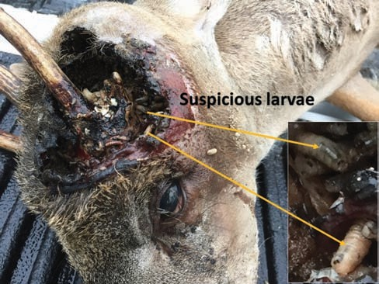

Fig. 1. Photograph of Key deer with myiasis that was received in an e-mail to the authors on September 30, 2016.

Florida Department of Agriculture and Consumer Services (FDACS), USDA-APHIS-International Services (APHIS-IS), Panama-United States Commission for the Eradication and Prevention of Screwworm (COPEG), and ARS were contacted. Document preparation began for informing the public, for developing an interdiction station and for personnel to travel to the Florida Keys to determine the extent of the incident. Although not covered in the Incident Response, docu- ment preparations began for information sharing with the World Organization for Animal Health (OIE) as well as interstate and inter- national animal movement/trade considerations. Also of important consideration was the storm track of Hurricane Matthew.
On October 3, J.B.W. and S.R.S. arrived in Florida. While wait- ing in the airport to meet our contacts, J.B.W. communicated with COPEG and the Panama Minister of Agriculture to inform them that sterile screwworms’ releases would be required to contain and eradicate the outbreak; this began the process of obtaining neces- sary export permits for biological material from Panama. J.B.W. and
S.R.S. then traveled to an Incident Response meeting on Marathon Key where they met with the rest of the initial Incident Management Team (IMT; about 25 individuals) consisting of personnel of the APHIS-VS (Team Co-lead), FDACS (Team Co-lead), U.S. Fish and Wildlife Service (FWS), and Monroe County. We learned that from July 8 to October 6, 47 Key deer had been euthanized because of severe myiasis; the earliest suspected case in a deer occurred in early July, but was not reported. This represented a severe breakdown in reporting requirements by local veterinarians (USDA 2018). Also, some companion animals had been affected (two dogs, one cat, and one pet pig). The APHIS-VS, FDACS, and Monroe County personnel began formulating a plan to inform the local animal care facilities and institute animal movement controls. By October 4, a mandatory interdiction station, operated 24/7, was established and operating near Key Largo at mile marker 106 of the Overseas Highway to inspect all animals leaving the Keys.
Although screwworms are known to infest wildlife (Lindquist 1937), the emphasis has always been on livestock surveillance. Wildlife generally avoids humans, but many Key deer show no fear and readily come into close proximity. The significance of the loss of Key deer was emphasized by the attending FWS personnel as well as the Monroe County representatives. These deer are an endangered species (~1,000 individuals) that occur only on about 26 of the middle Florida Keys (Florida Fish and Wildlife Conservation Commission 2017, Harveson et al. 2006). About 75% of the Key

deer population is found on Big Pine Key and No Name Key (Lopez et al. 2004a, b, 2016), but they are good swimmers and move between islands in search of fresh drinking water and forage (U.S. Fish and Wildlife Service 2010). Key deer are protected within the National Key Deer Refuge with a local office on Big Pine Key (U.S. Fish and Wildlife Service 2006, 2015) and are endeared by the local people (Peterson et al. 2005, Harveson et al. 2007).
On October 4, J.B.W. and S.R.S. went to Big Pine Key, the focus of the original cases, to become acquainted with the local FWS staff and examine the local situation. The FWS veterinarian informed us that the Key deer were “in rut” (the mating season; a time of male conflicts over mating privilege) and that all cases of myiasis in deer, except one, were in injured males. We accompanied a FWS Biologist on a call reporting a “zombie deer,” the name locals used for an infested deer, assisted in the euthanasia of this infested Key deer, and accompanied the Biologist to the disposal area. We learned that all dead deer, including the infested animals, were placed in one
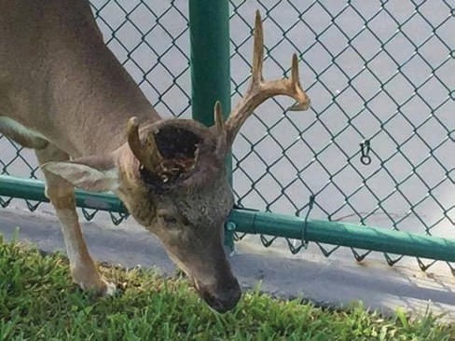

Fig. 2. A male Key deer severely infested with screwworms; an example of a “zombie deer.”
area, called the “bone yard,” to naturally decompose without any decontamination of the myiasis. We also learned that four more Key deer were euthanized during that day. Infested deer typically were discovered because they had large infestations of larvae that were third instars, resulting in the deer becoming severely debilitated (thus the term “zombie deer”; Fig. 2). Because third instars can success- fully pupate after leaving the wound on a dead animal, placing the infested deer carcasses on the ground at the “bone yard” effectively created a “screwworm factory” for fertile flies. From that point for- ward decontamination of Key deer was accomplished by freezing in a USDA-VS mobile freezing unit.
Noting that the first suspected screwworm infestation was in early July and considering the life cycle of screwworm (Laake et al. 1936), as well as the favorable climate, habitat and available hosts at the focus on Big Pine and No Name Keys, we calculated that by the time we arrived in October it was likely the screwworms had completed three to four generations. In addition, the use of the “bone yard” for disposal of untreated, infested deer likely added about 32,800 screw- worms to the environment (based on a conservative estimated aver- age 800 larvae per wound on each of the 41 deer carcasses). With an area of about 25.8 km2, Big Pine Key had an estimated screwworm population of >1,250 flies/km2. For successful control to occur and to achieve the standard ratio of 10 sterile flies:1 fertile fly for control,
~12,500 sterile flies/km2 would need to be released.
On October 5, the first attempt was made at collecting fertile screwworms using rotted beef liver as an attractant (Parker and Welch 1991a, b, 1992) (Fig. 3). Initially we used frozen beef liver (the only available source) and, as with previous attempts using frozen liver in other countries, we were unsuccessful (J. B. Welch, unpublished data). At the suggestion of the FWS veterinarian, we tried liver from the several Key deer that had just been euthanized and successfully collected a female screwworm within 1 h after bait deployment.
After analysis of satellite images (Phillips et al. 2004), 15 poten- tial locations for ground release chambers (GRC) for sterile screw- worm releases on Big Pine and No Name Keys, the known infested Keys, were provided by P.L.P. on October 6. Ground truthing and

Downloaded from https://academic.oup.com/jme/article-abstract/55/4/777/4989404 by guest on 15 May 2019
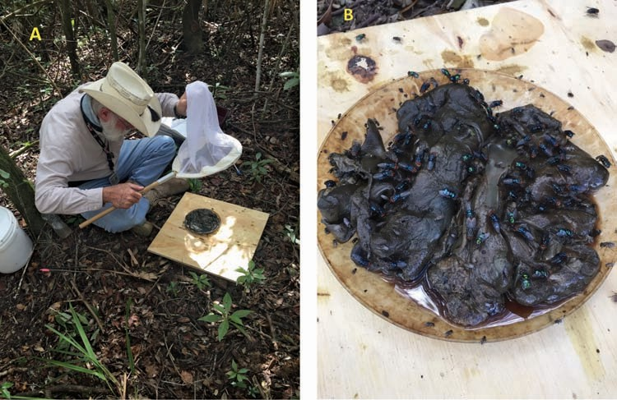

Fig. 3. Capturing flies using putrid liver (A) from euthanized Key deer. An example of the number of flies that can be attracted to the rotting liver (B).

selection of nine release chamber sites on Big Pine and No Name Keys was completed on October 7 (seven on Big Pine Key; two on No Name Key); GPS coordinates were recorded.
From October 4 to 6, an additional 21 Key deer were eutha- nized and the carcasses frozen in the mobile freezing units. In effect this began the eradication effort because about 16,800 screwworms were not liberated into the area. Also, the first shipment of sterile screwworms was scheduled to arrive from the Production Facility in Panama on October 10.
Plans were developed to collect samples of screwworm larvae from the tissue they infested. As most myiasis cases were in animal heads, heads of euthanized animals were collected on October 7–8 and placed within secure plastic containers (Fig. 4). These five boxes were kept within a sheltered area on the FSW National Key Deer Refuge property, without environmental controls, and were expected to produce enough pupae to establish a colony. When the larvae crawled from the wound they pupariated in the granulated material provided within the container (four each contained one Key deer

Downloaded from https://academic.oup.com/jme/article-abstract/55/4/777/4989404 by guest on 15 May 2019
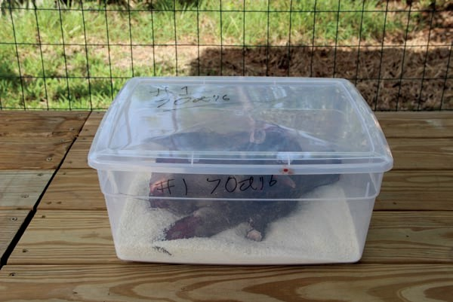

Fig. 4. One of the screwworm “rearing” boxes set up on Big Pine Key at the U.S. Fish and Wildlife Service property.
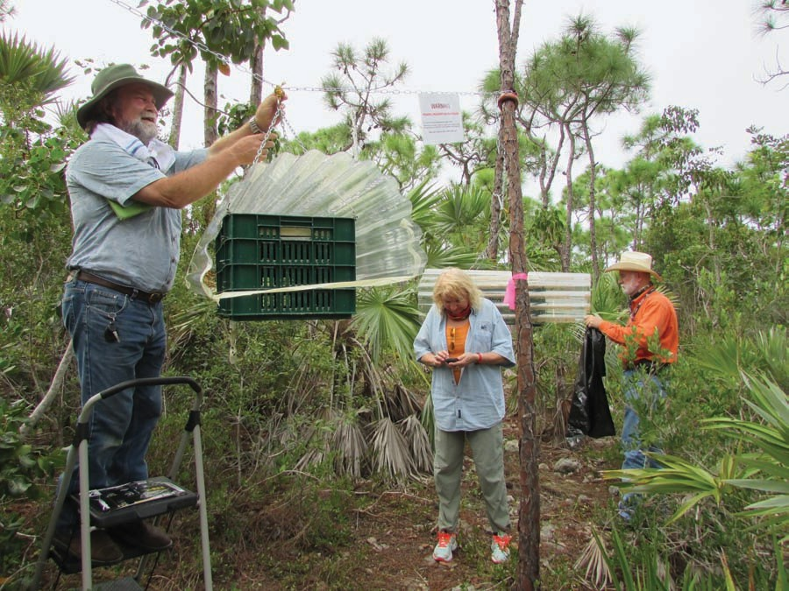

Fig. 5. Sterile fly release chambers used during the 2016 outbreak in the Florida Keys.

head and one contained a pig head; Fig. 4). Pupae would be recov- ered on October 9 and prepared to be sent to the ARS Laboratory in Panama to establish a colony (named Big Pine) to test for mat- ing compatibility with the current mass reared strain (Jamaica-06). Additional larval samples were collected and preserved in 95% etha- nol for future genetic analyses.
On October 8, J.B.W. and S.R.S. concentrated on collecting fer- tile female screwworms using sweep nets at rotting deer liver stations from one site on Big Pine Key. In about 4 h they collected 15 female screwworms.
On October 9, P.L.P. arrived on site and we initiated setup of ster- ile fly GRC (Fig. 5). Each of the seven sites on Big Pine Key and two sites on No Name Key were to have two release chambers (Fig. 6).
The authors participated in an information meeting for the public, led by the Commissioner of the Florida Department of Agriculture and Consumer Services along with other Federal, State and County representatives, early in the day on October 10. Then,
with the help of three APHIS-VS technicians, we completed setup of the nine release chambers. Three technicians from COPEG arrived, their main duties being to assist with distribution of sterile pupae to the GRCs, to assist in collecting adult screwworms at liver bait stations and to provide other necessary support. Later that day, on information from the FWS veterinarian, we returned to the FSW National Key Deer Refuge property and collected ≥10 larvae for genetic analyses from each of five infested Key deer that were eutha- nized. Also, the pupae from the five rearing boxes established on October 7–8 were collected, placed in individual, sealed, labeled, plastic containers and these containers were placed into a metal lock-box for transport to Panama on the return flight of the air- plane that would deliver the sterile pupae. The Incident Commander requested that S.R.S. consider returning to Kerrville, Texas to begin genetic analysis of the screwworm samples.
The first shipment of sterile flies arrived at the airport on Marathon Key on October 10. This first shipment consisted of 9,

Downloaded from https://academic.oup.com/jme/article-abstract/55/4/777/4989404 by guest on 15 May 2019
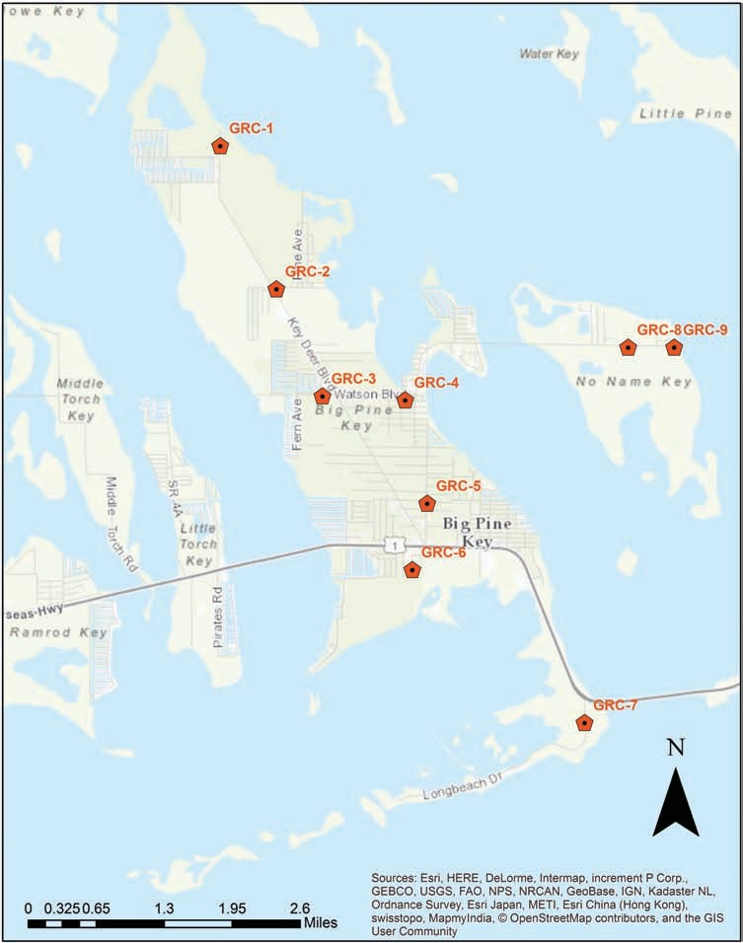

Fig. 6. Locations of ground release chambers on Big Pine (seven sites) and No Name Keys (two sites). Each location had two release chambers.

48-liter ice chests each containing ice packs to keep the 38 liters of flies/ice chest at ~10°C (temperature recorders were in each ice chest); this temperature reduced physiological function of the pupae, so that adults did not emerge during the 5-h flight from Panama. On arrival at the airport, the ice chests containing pupae were stored in a refrigerated trailer at 10°C until distribution to the GRCs the next morning. All 18 chambers, 2 at each of the 9 sites, were successfully filled with sterile pupae (Fig. 7). Each release chamber received about
9.5 liters of pupae; based on the average of 8,000 pupae per liter, there were ~76,000 pupae per chamber. Then, on receiving a report of an infested deer on Big Torch Key, J.B.W. went to collect adults coming to rotted deer liver; within 1.5 h four fertile females were collected. Based on this information, P.L.P. began to analyze where to establish GRCs on this island complex that was directly west of Big Pine Key.
Successful emergence of adults from the sterile pupae was deter- mined for each GRC on October 12–13. On average, there was ≥90% emergence of flies on this first effort. The release chambers were refilled twice weekly; thus, ~ 2,653,920 sterile flies were released weekly at the epicenter of the outbreak. Refilling twice weekly effect- ively mimics the current aerial releases of sterile flies by COPEG in the buffer zone at the Panama–Colombia border (Smith 2009) as supported by recent research (Skoda et al. 2017). The COPEG technicians and the authors also worked to establish a temporary laboratory space in the Big Pine Key Park Community Center. The temporary laboratory space was used to evaluate adult emergence from puparia, effect repairs to GRCs and other tasks as required.
We also reevaluated the one aspect of the outbreak that was in our favor; the focus was separated from the other Keys leading to the mainland by the Seven Mile Bridge. Yet we decided that there should be GRCs located on Marathon Key, the first Key east of the Seven Mile Bridge and toward the mainland, to better establish and reinforce this barrier. P.L.P. identified four sites where GRCs were subsequently located, one chamber at each site.
P.L.P. and S.R.S. departed the Keys on October 14.
J.B.W. remained to direct overall field activities including continu- ation of sampling for fertile adults on other Keys frequented by Key deer as well as assessing the distribution of sterile screwworms by collecting screwworms attracted to putrid liver; he was assisted in
these assessments by the COPEG Technicians. By October 28, they had determined that 11 additional Keys (now 13 total; 43 Keys were sampled) had fertile screwworms; all Keys positive for fertile screw- worms were west of the Seven Mile Bridge (west of the barrier).
P.L.P. continued analyses of the habitat of these Keys and GRCs were placed on each Key with positive infestations or fertile fly capture (Fig. 8). In all there were 30 sterile fly ground release sites, 26 on the 13 infested Keys and 4 in the barrier zone on Marathon Key. Also, by the end of October, the USDA-APHIS and USFWS had estab- lished doramectin treatment stations for ad libitum Key deer treat- ment; this was, in part, in response to public concern that Key deer mortality was very high (~100 by October 30) and several pets had been infested (five dogs, two cats, and two pet pigs). Residents also contributed to the doramectin treatments when feeding Key deer; in general, the residents were not only supportive but helpful.
A Big Pine screwworm colony was successfully established from the pupae that were sent to Panama. Following in-house ARS pro- tocols (Mastrangelo et al. 2012, Supplemental file 1, USDA-ARS Protocol for Responding to a Screwworm Outbreak), three replicates of reciprocal crosses were done to determine mating compatibility of the Big Pine (BP) colony with the mass-produced strain Jamaica-06 (J-06). A multivariate analysis of variance (MANOVA; SAS 2015) was used to evaluate the responses of total egg weight and egg hatch for the treatment variables of mating of 5 J-06 males and 15 females (control 1), 5 BP males and 15 females (control 2), 5 J-06 males with 15 BP females, and 5 BP males with 15 J-06 females. Overall there were no significant differences in egg weight (F = 3.4, P = 0.07) or egg hatch (F = 0.45, P = 0.7) from any of the crosses although, as expected, the matings of J-06 males and females did tend to deliver higher egg weights compared with all other mating combinations (Table 1). The specific test (multivariate contrast) comparing matings of J-06 males and females with J-06 males and BP females produced a consistent, borderline, nonsignificant difference in egg weights (F = 4.54, P = 0.05) but no difference in egg hatch (F = 1.57, P = 0.25) although test values varied (Table 1). This specific test confirmed that the J-06 strain was compatible with the BP flies and sterile releases would successfully eradicate the outbreak. These results are similar to previous reports (Mastrangelo et al. 2012) including results for the screwworm outbreak in Libya where the source was unknown

Downloaded from https://academic.oup.com/jme/article-abstract/55/4/777/4989404 by guest on 15 May 2019
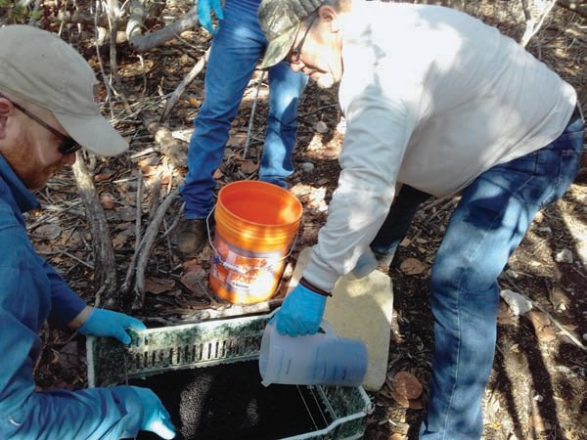

Fig. 7. Charging a sterile fly release chamber. Each chamber held about 76,000 sterile screwworm pupae.

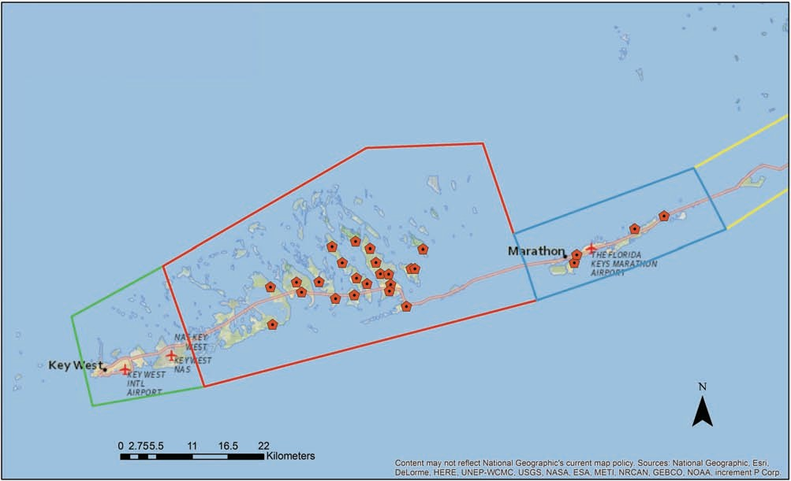

Fig. 8. The screwworm infested zone ( ), barrier/North surveillance zone ( and ) and South surveillance zone () in the Florida Keys. Sterile screwworm release chambers were located in the infested zone and the barrier zone.

Table 1. Resultant total egg production, average egg weight (mg)
Downloaded from https://academic.oup.com/jme/article-abstract/55/4/777/4989404 by guest on 15 May 2019
± SD, and average percentage hatch ± SD, from three replicated crosses of the mass production strain (J-06) with the line estab- lished from Florida outbreak collected from Big Pine Key (BP)

Cross (♂male × ♀female)a | Egg weight (mg) ± SD | % egg hatch ± SD
♂J-06 × ♀J-06 (control 1) | 116.7 ± 53.8 | 89.67 ± 5.86
♂BP × ♀BP (control 2) | 45.67 ± 5.13 | 84.93 ± 15.67
♂J-06 × ♀BP | 35.0 ± 12.49 | 78.0 ± 17.06
♂BP × ♀J-06 | 59.67 ± 39.37 | 90.27 ± 3.93
Overall average | 64.25 ± 43.86 | 85.72 ± 11.53
aFive males were mated to 15 females in each replication of all crosses.

(Taylor et al. 1991). This result is also supported by the field obser- vation of a rapid reduction of myiasis cases in the infested area of the Keys soon after sterile fly releases commenced (Fig. 9).
On return to Kerrville, TX, S.R.S. began genetic analysis of the samples collected on October 10. The approach used, polymerase chain reaction restriction fragment length polymorphism of two amplicons of the mtDNA (~2,360 bp region that included the com- plete sequence of the cytochrome oxidase c subunits 1 and 2 and
~2,100 bp of the complete control region and partial rRNA 12S sequence), was duplicated as reported by Lyra et al. (2009). In their work, Lyra et al. (2009) reported high frequencies of two haplotypes from Caribbean islands that, if they occurred in the Florida Keys outbreak samples, would have been supportive of the hypothesis of the outbreak’s origin was from a Caribbean nation. The two haplo- types were not in high frequency in the Florida outbreak samples, so this hypothesis was not supported. Collaborators, using these same and additional samples from the outbreak, sequenced the
mitochondrial genes COI and COII plus the nuclear gene EF1α, but were also unsuccessful in determining the outbreak’s origin (unpub- lished report). Future work is planned with these samples. A larger library of genetic “fingerprints” should be developed, so that, if needed, there is a higher probability of determining a region from which and outbreak originated.
Although an epidemiological investigation was undertaken (Delgado et al. 2016), no conclusive point of entry to the Keys could be confirmed. Sterile fly releases continued, twice weekly, with an excel- lent response (Fig. 9A). By late November, it appeared that the fertile screwworm population was responding similarly to previous out- breaks on Aruba where GRCs were used (Fig. 9B). Sampling for adult screwworms using putrid liver was continued daily both to detect the distribution of sterile flies and to monitor for fertile flies in different Keys in the infested zone, in the barrier zone, and in the Northern and Southern surveillance zones. A total of 457 fly assessments were per- formed, on 43 different islands of the Keys, representing over 1,000 work hours. The last fertile fly was collected on November 7, but ster- ile screwworms were collected until the final assessment in March. The IMT interdiction station inspected more than 6,200 animals and found no cases of myiasis. Sterile fly releases in the barrier zone, Marathon Key, ended on December 26, 2016. However, on January 6, 2017 a dog with screwworm myiasis was found near Homestead, FL (just south of Miami and on the mainland).
On January 7, J.B.W. and the COPEG technicians arrived at the Homestead location (Fig. 10). Investigation showed that the infested dog was a stray, recovered by a local resident, which was taken to a veterinarian on December 19. The veterinarian extracted nine larvae, and treated the wound, but the larvae were not submitted to NVSL until January 5, when the larvae confirmed to be screwworm. This, again, was a breakdown in veterinary reporting requirements (USDA

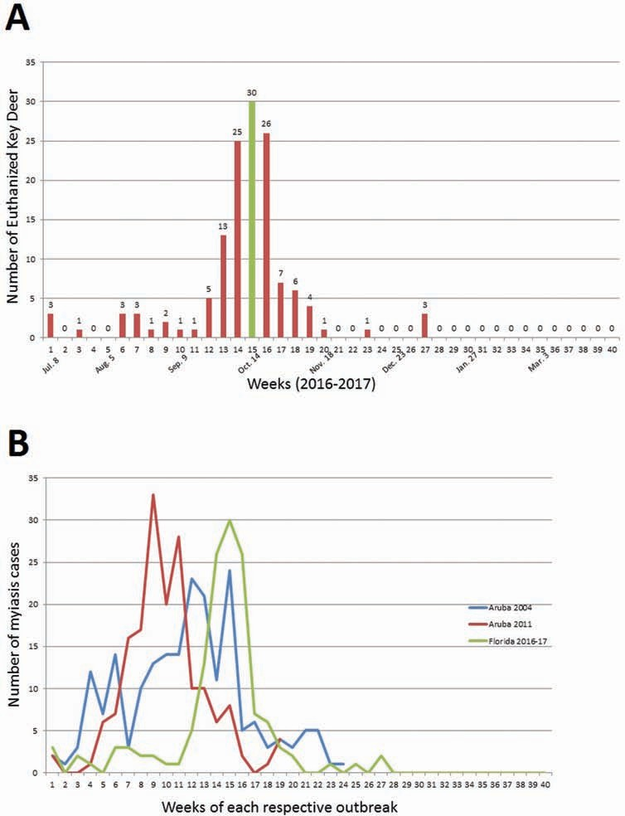

Fig. 9. Weekly cases of screwworm myiasis during the Florida Key outbreak (A; the green bar at week 15 denotes the first releases of sterile screwworms) and a comparison of the Florida Key outbreak to two previous outbreaks in Aruba (B) where ground release chambers were also used.

2018). On inspection of the area where the dog was housed prior to being taken to the veterinarian 19 empty puparia and 13 dead, adult screwworms (four males and nine females) were found. With this evidence, that fertile flies had been released into the environment,
Downloaded from https://academic.oup.com/jme/article-abstract/55/4/777/4989404 by guest on 15 May 2019
P.L.P. was consulted and four sterile screwworm GRCs sites were identified. On January 11, J.B.W. and COPEG team started ground- truthing the four sites and one fertile screwworm male was collected at one of the locations. The GRCs on the Florida peninsula were deployed on January 13 (Fig. 10). J.B.W. and the COPEG technicians began concentrated monitoring with putrid liver and the IMT started an extensive public relations campaign. Finally, in case of the possible worst case scenario, plans were developed for potential aerial disper- sal of sterile screwworms on the Florida peninsula. After ~500 h of surveillance, consisting of 279 separate fly assessments by collection at putrid liver, no other fertile screwworms were collected nor were
any new cases of myiasis reported on the Florida peninsula. Sterile fly releases were discontinued around Homestead on March 17, 2017.
No new myiasis cases were discovered in Key deer after January 10, 2017. Overall, there were 135 Key deer euthanized during this event, roughly 10% of the population, and a FWS Biologist esti- mated that for each known detected death there was at least one undetected in nature. The Interdiction Station closed on March 19, 2017 (having inspected >17,000 animals), and the USDA declared eradication of the outbreak on March 23, 2017 (USDA 2017). In part because of the special situation with Key deer and the “fawn- ing” season, sterile fly releases continued in the infested zone of the Florida Keys until April 25, 2017. In all, about 194.2 million pupae were delivered to GRCs, from which roughly 188.4 million sterile flies emerged and were released (176.5 million in the infested zone, 5.5 million in the barrier zone and 6.1 million around Homestead).

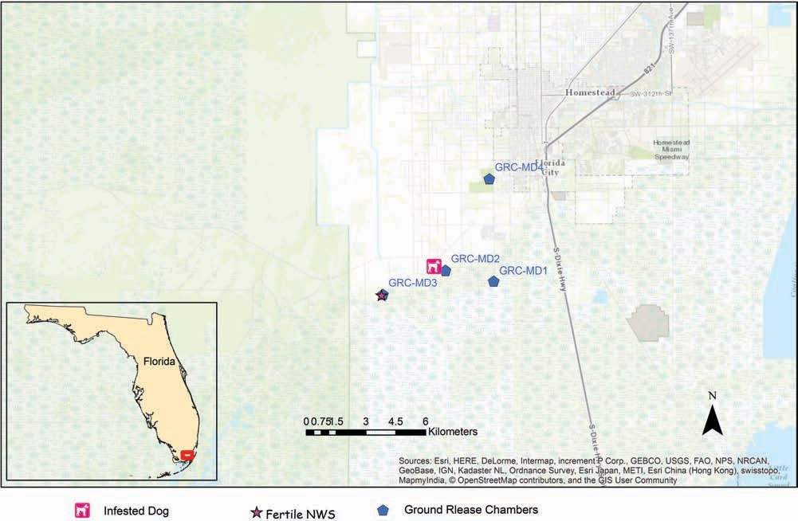

Fig. 10. Location of Homestead, FL where screwworm-infested dog was discovered in relation to the original infested area of the Florida Keys, the location of the capture of one fertile male screwworm and locations of sterile screwworm ground release chambers around the Homestead location.

This was the first screwworm outbreak in the United States to be eradicated using GRCs to distribute sterile screwworms. Although pupae shipped from Panama to Florida were chilled for 34–66 h before placement in the field, overall emergence of adults from puparia was 97%. In the Keys sterile flies maximally dispersed
Downloaded from https://academic.oup.com/jme/article-abstract/55/4/777/4989404 by guest on 15 May 2019
~32 km, while on the mainland maximum dispersal was ~15 km; more sterile flies were collected downwind from release sites than upwind. In the Keys there were 457 fly assessments by collecting flies attracted to putrid liver, while around the Homestead area there were 279 fly assessments. More than 17,000 animals were inspected at the interdiction station. USDA-APHIS invested ~$3.15 million over the duration of the outbreak (USDA 2017), but the cost to the
U.S. economy was inestimable had this response not been successful. The breakdown in reporting requirements by local veterinar- ians is being addressed at various levels, State and Federal, but the authors are not directly involved in this process. Lessons learned during this outbreak response will be incorporated into revisions of the APHIS and ARS outbreak response protocols. Finally, intensive sampling, particularly from Caribbean Islands where screwworm is endemic, is planned with the intent of developing a more informative
genetic library.

Supplementary Data
Supplementary data are available at Journal of Medical Entomology
online.

Acknowledgments
Agustin Sagel and the rest of the ARS staff in Panama supported rearing of the Big Pine line for mating compatibility tests with the mass production line
for which the authors are grateful. The entire COPEG staff, particularly the Technicians of the Technical Direction, also provided critically important sup- port. Mention of a proprietary product does not constitute endorsement or recommendation for its use by the USDA. USDA is an equal opportunity pro- vider and employer.

References
Alexander, J. L. 2006. Zoonosis update: screwworms. JAVMA. 288: 357–367. Baumhover, A. H. 2001. A personal account of programs to eradicate the screwworm, Cochliomyia hominivorax, in the United States and Mexico with special emphasis on the Florida Program. Florida Entomol. 85: 666–
673. http://journals.fcla.edu/flaent/article/view/%2074953/72611
Baumhover, A. H. 2002. A personal account of developing the sterile insect technique to eradicate the screwworm from Curacao, Florida and the Southeastern United States. Florida Entomol. 84: 666–673. file:///C|/web- baum5/baumhover(k).html (1 of 24) [12/7/2000 12:27:04 PM]
Bram, R. A., and J. E. George. 2000. Introduction of nonindigenous arthropod pests of animals. J. Med. Entomol. 37: 1–8. doi:10.1603/0022-2585-37.1.1 Bushland, R. C. 1975. Screwworm research and eradication. Bull. Entomol.
Soc. Am. 21: 23–26. doi:10.1093/besa/21.1.23
Christy, G. 2012. New World screwworm (NWS) exercise in Florida. http://www.usaha.org/upload/Committee/ForeignEmerging/Christy- ScrewwormExercise-FED2012.pdf (accessed 9 April 2018).
Coppedge, J. R., J. L. Goodenough, A. B. Broce, F. H. Tannahill, J. W. Snow, M.
M. Crystal, and H. D. Petersen. 1978. Evaluation of the screwworm adult suppressions system (SWASS) on the island of Curacao. J. Econ. Entomol. 71: 579–584.
Cushing, E. C., and W. S. Patton. 1933. Studies on the higher Diptera of med- ical and veterinary importance: Cochliomyia americana sp.nov., the screw- worm fly of the New World. Ann. Trop. Med. Parasitol. 27: 539–551.
Dear, J. P. 1985. A revision of the New World Chrysomyini (Diptera: Calliphoridae). Revta Bras. Zool. 3: 109–169.

Delgado, A., M. Hennessey, and D. Hsi. 2016. Investigation into introduction of New World screwworm into Florida keys. USDA-APHIS, Riverdale, Maryland. https://www.aphis.usda.gov/stakeholders/downloads/2017/ nws-epi-report.pdf
Downloaded from https://academic.oup.com/jme/article-abstract/55/4/777/4989404 by guest on 15 May 2019
Dove, W. E., and D. C. Parman. 1935. Screw worms in the Southeastern states.
J. Econ. Entomol. 28: 765–772.
Florida Fish and Wildlife Conservation Commission. 2017. Imperiled Species: Key Deer, Odocoileus virginianus clavium. http://myfwc.com/ wildlifehabitats/imperiled/profiles/mammals/key-deer/
Francesconi, F., and O. Lupi. 2012. Myiasis. Clin. Microbiol. Rev. 25: 79–105. doi:10.1128/CMR.00010-11.
Graham, O. H. 1985. Symposium on eradication of the screwworm from the United States and Mexico. Misc. Publ. Entomol. Soc. Am. 62: 68 p.
Harveson, P. M., W. E. Grant, R. R. Lopez, N. J. Silvy, and P. A. Frank. 2006. The role of dispersal in Florida Key deer metapopulation dynamics. Ecol. Modeling 195: 393–401.
Harveson, P. M., R. R. Lopez, B. A. Collier, and N. J. Silvy. 2007. Impacts of urbanization on Florida key deer behavior and population dynamics. Biol. Conserv. 134: 321–331.
King, W. V., and G. H. Bradley. 1935. The screw worm outbreak in Florida. J. Econ. Entomol. 28: 773–777.
Laake, E. W., E. C. Cushing, and H. E. Parish. 1936. Biology of the pri- mary screw worm fly, Cochliomyia americana, and a comparison of its life stages with those of C. macellaria. Tech. Bull. No. 500, U.S. Dept. of Agric., Washington, D.C.
Lindquist, A. W. 1937. Myiasis in wild animals in southwestern Texas. J. Econ.
Entomol. 30: 735–740.
Lindquist, D. A., and M. Abusowa. 1992. Eradicating the new world Screwworm from the Libyan Arab Jamahiriya: a look at how an inter- national programme protected North Africa’s wildlife and livestock from a “worm of death”. IAEA Bull., 4: 17–24.
Lopez, R. R., N. J. Silvy, B. L. Pierce, P. A. Frank, M. T. Wilson, and K.
M. Burke. 2004a. Population density of the endangered Florida Key deer.
J. Wildl. Manage. 68: 570–575.
Lopez, R. R., N. J. Silvy, R. N. Wilkins, P. A. Frank, M. J. Peterson, and M.
N. Peterson. 2004b. Habitat use patterns of Florida Key deer: implications of urban development. J. Wildl. Manage. 68: 900–908.
Lopez, R. R., I. D. Parker, N. J. Silvy, B. L. Pierce, J. T. Beaver, and A. A. Lund. 2016. Florida key deer screwworm final report (Phase I). Texas A&M Institute of renewable natural resources. College Station, Texas. 40 p. https://nri.tamu.edu/media/1321/final-key-deer-screwworm-final-report- phase-i.pdf
Lyra, M. L., L. B. Klaczko, and A. M. Azeredo-Espin. 2009. Complex pat- terns of genetic variability in populations of the New World screwworm fly revealed by mitochondrial DNA markers. Med. Vet. Entomol. 23 (Suppl 1): 32–42.
Manrique, J. C. 2000. Screwworm: progress in its eradication, risks of infest- ation and its prevention in the Americas. Conf. OIE 2000, Paris, France, 193–200.
Mastrangelo, T., M. F. Chaudhury, S. R. Skoda, J. B. Welch, A. Sagel, and J.
M. Walder. 2012. Feasibility of using a Caribbean screwworm for SIT campaigns in Brazil. J. Med. Entomol. 49: 1495–1501.
Mastrangelo, T., and J. B. Welch. 2012. An overview of the components of AW-IPM campaigns against the New World Screwworm. Insects 3: 930– 955. doi:10.3390/insects3040930.
Parker, F. D., and J. B. Welch. 1991a. Alternative to sentinel animals for collecting egg masses from wild females of the screwworm (Diptera: Calliphoridae). j. Econ. Entomol. 84: 1476–1479.
Parker, F. D., and J. B. Welch. 1991b. Field comparisons of attractants for the screwworm fly (Diptera: Calliphoridae) in a tropical dry forest in Costa Rica. J. Econ. Entomol. 84: 1189–1195.
Parker, F. D., and J. B. Welch. 1992. Monitoring adult populations of the screwworm (Diptera: Calliphoridae) with feeding stations baited with liver. J. Econ. Entomol. 85: 1740–1753.
Peterson, M. N., R. R. Lopez, E. J. Laurent, P. A. Frank, N. J. Silvy, and J. Liu. 2005. Wildlife loss through domestication: the case of endangered Key deer. Conserv. Biol. 19: 939–944.
Phillips, P. L., J. B. Welch, and M. Kramer. 2004. Seasonal and spatial distribu- tions of adult screwworms (Diptera: Calliphoridae) in the Panama canal area, republic of Panama. J. Med. Entomol. 44: 121–129.
Reichard, R. E. 1999. Case studies of emergency management of screwworm.
R. Sci. Tech. Off. Intern. Epizoot. 18: 145–163.
SAS Institute Inc. 2015. Base SAS® 9.4 procedures guide. SAS Institute Inc., Cary, NC.
Scott, M. J., C. Concha, J. B. Welch, P. L. Phillips, and S. R. Skoda. 2017. Research advances in the screwworm eradication program over the past 25 years. Entomol. Exp. Appl. 164: 226–236. doi:10.1111/eea.12607.
Skoda, S. R., P. L. Phillips, A. Sagel, and M. F. Chaudhury. 2017. Distribution and persistence of sterile screwworms released at the Panama-Colombia border. J. Econ. Entomol. 110: 783–789. doi:10.1093/jee/tow309.
Smith, S. C. 2009. A guide for the eradication of screwworms. Comision Mexico - Americana para la Eradicacion del Gusano Barrenador, Tuxtla Gutierrez, Mexico. http://www.flsart.org/screwworm/Screwworm%20 Eradication%20Guide%20Print%20Version.pdf
Snow, J. W., J. R. Coppedge, A. H. Baumhover, and R. Gorsira. 1978. The screwworm Cochliomyia hominivorax (Diptera: Calliphoridae) reinfests the island of Curaçao, Netherlands Antilles. J. Med. Entomol. 14: 592–593.
Taylor, D. B., L. Hammack, and R. L. Roehrdanz. 1991. Reproductive com- patibility and mitochondrial DNA restriction site analysis of New World screwworm, Cochliomyia hominivorax, from North Africa and Central America. Med. Vet. Entomol. 5: 145–151.
USDA-APHIS. 2016a. New World screwworm ready reference guide - his- torical economic impact. USDA APHIS Veterinary Services National Preparedness and Incident Coordination (NPIC) 4700 River Road Unit 41, Riverdale, MD 20737, https://www.aphis.usda.gov/animal_health/ emergency_management/downloads/screwworm_rrg.pdf
USDA-APHIS. 2016b. New World screwworm ready reference guide – maps & timelines. USDA APHIS Veterinary Services National Preparedness and Incident Coordination (NPIC) 4700 River Road Unit 41, Riverdale, MD 20737, https://www.aphis.usda.gov/animal_health/emergency_manage- ment/downloads/screwworm_rrg.pdf
USDA-APHIS. 2017. Final report for the APHIS Veterinary Services response to the 2016–2017 outbreak of New World screwworm (NWS) in Florida: Public version. National Preparedness and Incident Coordination, Veterinary Services, Animal and Plant Health Inspection Service, U.S. Department of Agriculture, 4700 River Road, Unit 41, Riverdale, MD, https://www.aphis.usda.gov/animal_health/emergency_management/ downloads/public-nws-usdaaphis-final-report.pdf
USDA-APHIS. 2018. The foreign animal disease preparedness and response plan - disease response strategy: New World screwworm Myiasis. National Preparedness and Incident Coordination, Veterinary Services, Animal and Plant Health Inspection Service, U.S. Department of Agriculture, 4700 River Road, Unit 41, Riverdale, MD, https://www.aphis.usda.gov/animal_ health/emergency_management/downloads/nws_myiasis_disease_strat- egy.pdf
U.S. Fish and Wildlife Service. 2006. Habitat conservation plan for Florida Key deer (Odocoileus virginianus clavium) and other protected species on Big Pine Key and No Name Key, Monroe County, Florida. U.S. Fish and Wildlife Service, 1339 20th Street, Vero Beach, Florida 32960. http://www. monroecounty-fl.gov/DocumentCenter/Home/View/1286
U.S. Fish and Wildlife Service. 2010. Key deer (Odocoileus virginianus clavium) 5-year review: summary and evaluation. U.S. Fish and Wildlife Service, 1339 20th Street, Vero Beach, Florida 32960. https://www.fws. gov/southeast//pdf/five-year-reviews/key-deer.pdf
U.S. Fish and Wildlife Service. 2015. National key deer refuge. https://www. fws.gov/refuge/National_Key_Deer_Refuge/about.html#
Vargas-Teran, M., H. C. Hofmann, and N. E. Tweddle. 2005. Impact of screw- worm eradication programmes using the sterile insect technique: sterile Insect Technique, pp. 629–650. In V. A. Dyck, J. Hendrichs, and A. S. Robinson (eds.), Principles and practice in area-wide integrated pest man- agement. Springer, Dordrecht.
Whitworth, T. 2010. Keys to the genera and species of blow flies (Diptera: Calliphoridae) of the West Indies and description of a new species of Lucilia Robineau-Desvoidy. Zootaxa 2663: 1–35.

